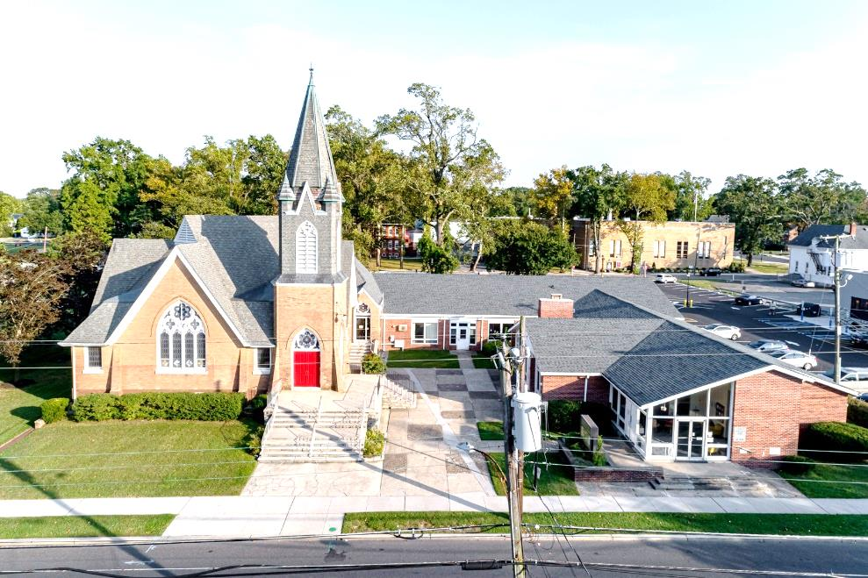

The Presbyterian Church at Hammonton
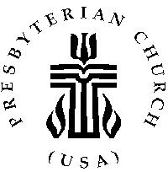

Our vision is to open our doors to all seeking a spiritual home of worship and to carry the light and love of Jesus Christ, our Savior, throughout the community.

MISSION STATEMENT
We are committed to Jesus Christ and the growing of his Church by glorifying God and by proclaiming the good news of the gospel through word and deed. We involve and reach out to our members and our community in Christ’s name through worship, Christian Education, and stewardship to support the mission of our church.

Note: Special thanks to Rev. Dr. Scott Morschauser for leading us in worship today.

Organist: Cindy Birnbaum
Sunday School Superintendent: Beth Burkett-Rice

2022 2023 2024
ELDERS
Eric Copenhaver Robert Bauers Sallye Hershman
Marylee Kondrach Dorrine Esposito Paul Moul
Charles Muller Richard Walker Johanna Johnson

DEACONS
Elsie Bakley Wendy Copenhaver Hilda Lugo
Nancy Foster Ann DiMeo Carol Orsi
Margaret Jones Rebecca Lindstrom Rebecca Villani

Clerk of Session: Beth Burkett-Rice

Church Office: 326 Bellevue Avenue, Hammonton, NJ
Office hours: Tuesday - Thursday 9:30 AM to 12:30 PM
Phone (609) 561-0168 ~ Fax (609) 561-6105
e-mail: office@hammontonpres.org
website: www.hammontonpres.org

THE CELEBRATION OF WORSHIP
AUGUST 7TH, 2022
9th SUNDAY AFTER PENTACOST
VIRTUAL & LIVE SERVICE
11:00am
****************************************************
~ GATHERING IN GOD’S NAME ~
“Welcome to the Presbyterian Church at Hammonton, we are glad you are able to join us. As we gather for worship feel free to pray and meditate on God’s calling in your life. Be respectful of others around you who might be doing the same, prior and during the Prelude, keeping your voice and conversation soft and to a minimum.”
PRELUDE ~“The Penitent Heart”- C. Curtis
“Heaven’s Bread” – S. Keeney
“Glorious Things of Thee Are Spoken”- R. Hughes

~ TIME FOR CENTERING STILLNESS AND SILENCE ~

WELCOME AND ANNOUNCEMENTS

*THE PEACE
Let the people greet one another by staying in their seats and saying: “Peace be with you!”

~ HUMBLY APPROACHING GOD ~

OPENING PRAYER

* CALL TO WORSHIP
One: Make us to know your ways, O Lord;
All: Teach us your paths.
One: Lead us in your truth and teach us.
All: For in Christ Jesus, you are the God of our salvation. For you we wait all the day long.
One: Good and upright is the Lord.
All: He leads the humble in what is right. He teaches the humble his way.
One: All the paths of the Lord are steadfast love and faithfulness.
All: In, and through, and as your Son, is the Way, the Truth and the Life. In our dear and faithful Savior, God's covenant is kept for our sake, through him, God's testimonies to us are revealed.

*HYMN #150 ~ “Come, Christians Join to Sing”

CALL TO CONFESSION
If we say we have no sin, we deceive ourselves and the truth is not in us. Yet, if we confess our sins, God is merciful and just. He will forgive our sins and cleanse us of all unrighteousness. Hearing of God's mercy to us in Jesus Christ, let us confess our sins; first together as the church, then each of us in the silence of our hearts. Let us pray:

PRAYER OF CONFESSION
Gracious and Everlasting God: We give you thanks that you are not a God who is far away, but who has come near in your dear Son. Forgive us when we would distance ourselves from you, thinking that there are places in our lives outside of your lordship. Have patience with us when we, who have received mercy, fail to be a neighbor to the suffering whom you call us to be near. By your Spirit, help us to grasp that eternal life is not just about a time in the distant future, but is here and now, when we act according to the call of Christ, in whose name, we pray. Amen.
(silent confession)

ASSURANCE OF FORGIVENESS
Who is in a position to condemn us? Only Christ. Yet Christ died for us. Christ rose for us. Christ reigns in his merciful power over us. Jesus Christ himself prays for us. Anyone who is in Christ is a New Creation: the old life of sin has no claim on us anymore. The New Life in Christ has surely come, because in and through Jesus Christ our sins are forgiven. Amen.

*GLORIA PATRI – #577 – Avery & Marsh
Glory be to the Father and to the Son and to the Holy Ghost; as it was in the beginning is now and ever shall be, world without end. Amen.

CHILDREN’S MESSAGE

~ RECEIVING GOD’S WORD ~

PRAYER OF ILLUMINATION

SCRIPTURE READINGS Deut. 30:11-20 (OT, 183-184)
Luke 10:25-37 (NT, 68)

MESSAGE ~ “Path to Life” –
Rev. Dr. Scott Morschauser

~ RESPONDING TO THE WORD ~

*AFFIRMATION OF FAITH

JOYS AND CONCERNS OF THE CHURCH

PRAYERS OF THE PEOPLE

THE OFFERING OF OUR GIFTS AND OURSELVES

OFFERTORY ~ “Jesus, Keep Me Near the Cross” – R. James

*DOXOLOGY (#592)
Praise God, from whom all blessings flow; Praise Him, all creatures here below; Praise Him above, ye heavenly host; Praise Father, Son, and Holy Ghost. Amen.

PRAYER OF DEDICATION OF GIFTS AND SELF

~ THE LORD’S SUPPER ~

INVITATION TO THE TABLE

*HYMN #302 ~ “I Danced in the Morning”

GREAT PRAYER OF THANKSGIVING

DISTRIBUTION OF THE ELEMENTS

PRAYER AFTER COMMUNION

~ GOING IN GOD’S NAME ~

*HYMN #146 ~ “Rejoice Ye Pure in Heart”

* THE CHARGE & BENEDICTION - LORD’S PRAYER
Our Father, who art in heaven, hallowed be Thy name. Thy kingdom come, thy will be done, on earth as it is in heaven. Give us this day our daily bread; and forgive our debts as we forgive our debtors; and lead us not into temptation, but deliver us from evil. For Thine is the kingdom and the power and the glory, forever. Amen.

POSTLUDE~ “Guide Me, O Thou Great Jehovah” – D. Paxton

OUR WORSHIP HAS ENDED, LET OUR SERVICE BEGIN

*Signifies stand if comfortable.

Last Week’s Attendance & Offering:
Attendance: 30 people
Offering: $1,165.00
______________________________________________
CHURCH EVENTS
>>>THIS WEEK:
Monday-08/08:
9:00 AM Clothing Closet
-12:00 PM
7:30 PM ESL classes

Tuesday-08/09:
9:00 AM Clothing Closet
-12:00 PM

Wednesday-08/10:
9:00 AM Clothing Closet
-12:00 PM
7:30 PM ESL classes

______________________________________________

>>UPCOMING:
Monday-08/15:
9:00 AM Clothing Closet
-12:00 PM
7:30 PM ESL classes

Tuesday-08/16:
9:00 AM Clothing Closet
-12:00 PM

Wednesday-08/17:
9:00 AM Clothing Closet
-12:00 PM
7:30 PM ESL classes

______________________________________________
BIRTHDAYS:

August 10 Daniel Hershman
August 13 Isaac Sotelo
______________________________________________
ANNIVERSARIES:

No anniversaries this week.

SERVING YOU TODAY:

Liturgist: Shawn Hershman

Ushers: Darrell Hershman, Captain
Elsie Bakley
Mary Hershman
Emily Iacovone
Luke Iacovone
Susan Iacovone

